## RDS Team Dynamics *Bi-Weekly Update*

**Assignment Goals / Deliverables:** Continuing the theme set with our first Team Dynamics assignment, we want you to get together with your team for a social activity either in-person or virtually (whichever you feel comfortable with). You can share a meal together, play a game, or something along those lines. This gathering should help you unwind a little, and allow you to reflect upon how your team has been performing over the last two weeks. As deliverables, we ask that you complete the following two tasks and upload them to the Canvas assignment:

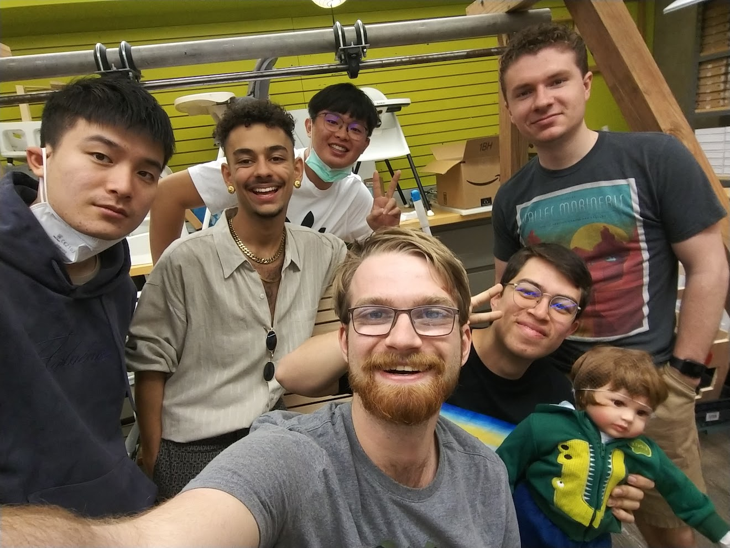

***Please be open and honest with yourselves and your group. There will be no penalties for the answers you provide in these bi-weekly updates, rather they should help you find areas for potential growth and help you recognize individual and team development.***

1. Have there been any conflicts or issues that have arisen within your team over the last two weeks? If so, what were they, and how were they resolved?

| No new conflicts have arisen. We continued to smooth out things from a previous conflict about workload and were able to balance out the workload really nicely for the presentations. |
| --- |

1. Are there any conflicts or issues within your team that are still outstanding that you would like to discuss during your next weekly meeting?

| No outstanding conflicts |
| --- |

1. Are there any areas where you feel your team is excelling?

| I think we did a good job in the presentations, the workload was shared pretty evenly, and every group member did a good job presenting the work that they had been focusing on. |
| --- |

1. Are there any areas where you feel your team needs improvement?

| We still could do better in actively communicating our availability, but we are doing better at understanding how to negotiate the workload. |
| --- |